**Azure Data Science Virtual Machines (DSVM)**

* **Preparation: Provision the Windows Data Science Virtual Machine on Azure**

<https://docs.microsoft.com/en-us/azure/machine-learning/data-science-virtual-machine/provision-vm>

* **Direct-Link to DSVM in the Azure Portal:**

<https://portal.azure.com/#create/microsoft-ads.windows-data-science-vmwindows2016>

* **Introduction to Azure Data Science Virtual Machine for Linux and Windows**

<https://docs.microsoft.com/de-de/azure/machine-learning/data-science-virtual-machine/overview>

* **Ten things you can do on the Windows Data Science Virtual Machine**

<https://docs.microsoft.com/de-de/azure/machine-learning/data-science-virtual-machine/vm-do-ten-things>

* **Samples on the Data Science Virtual Machines (DSVM)**

<https://docs.microsoft.com/de-de/azure/machine-learning/data-science-virtual-machine/dsvm-samples-and-walkthroughs>

* **Azure Data Science Virtual Machine Documentation (Step by Step Tutorials)**

<https://docs.microsoft.com/en-us/azure/machine-learning/data-science-virtual-machine/>

* **Data science with a Linux Data Science Virtual Machine on Azure**

<https://docs.microsoft.com/de-de/azure/machine-learning/data-science-virtual-machine/linux-dsvm-walkthrough>

* + **Connect to Linux DSVM with remote Desktop (Tutorial)**

<https://docs.microsoft.com/de-de/azure/virtual-machines/linux/use-remote-desktop>

connect to virtual machine using a secure shell, e.g. putty ([www.putty.org](http://www.putty.org)) with credentials shown in Azure Portal:

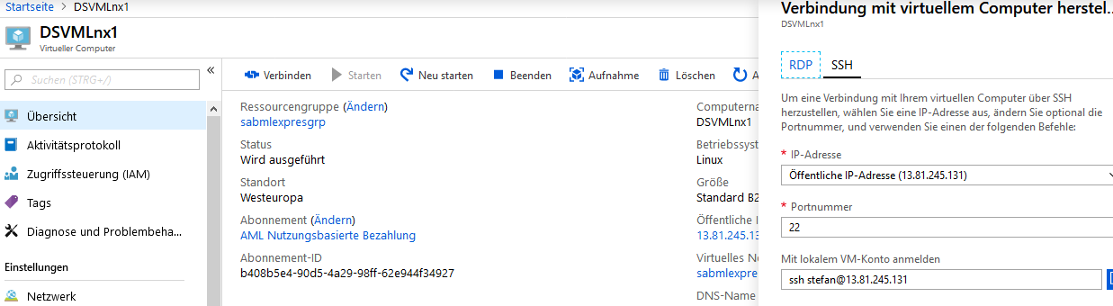

Proceed with the steps in the „Connect -Tutorial“ and relpace „azureuser“ with the username (indicated before the „@“-character)

Use Powershell from Azure Workbench (->File-> Open PowerShell) to open then necessary port for RDP (3389) in the firewall:

**az vm open-port --resource-group myResourceGroup --name myVM --port 3389**

**az vm open-port --resource-group sabmlexpresgrp --name DSVMLnx1 --port 3389**

or use the Azure portal to create a network security group if it does not already exist ( see next page)

* + either look at the following tutorial
  + **How to open ports to a virtual machine with the Azure portal**

<https://docs.microsoft.com/de-de/azure/virtual-machines/windows/nsg-quickstart-portal?toc=%2fazure%2fvirtual-machines%2flinux%2ftoc.json>

* Or click on your DSVM, click on „Network“ , click on „Add Rules for inbound port“

